Table of Contents
Project Description 2
Project Proposal 4
Appendix 1: Safe and Proctored Use of AI 7
Appendix 2: Value Proposition -- Why A Paid AI Model? 12
Appendix 3: Budget Breakdown & Technical Feasibility 14
Appendix 4: Sample Prompt and Output 19
Appendix 5: Why Gemini and not Chat GPT or Claude? 26

John C. Weisenfeld, Rebecca Riley, Joshua Gourley
Orion High School | 1901 E Salt Lake ST, Pasco, WA, 99301
Amentum Grant Proposal 2025-2026: Designing a Bus Stop With Help of AI
Can High School Students + Gemini Premium AI > City Planner?

Can High School Students + Gemini Premium AI > City Planner?

Project Description
Context & Population: This project will occur during school hours within the Physics and Engineering curriculum at Orion High School. It serves 150 students (primarily 9th grade) and runs from January 6, 2026, to May 31, 2026.
Real-World Problem: Students will redesign the unpaved, exposed, and unsafe "bus stop" (currently just a patch of dirt) across the street from our campus. This creates an immediate, tangible connection between STEM skills and their daily safety and comfort.
Major STEM Concepts: Students will learn Civil Engineering (load calculations, material science, foundation design), Architecture (ADA compliance, spatial reasoning), and Computer Science (Generative AI prompting, verifying algorithmic outputs).
Career Connections: The project directly simulates the workflows of Civil Engineers, Urban Planners, and Architects. By using our custom Enterprise AI tool rather than a free chatbot, students also gain experience as AI Specialists, learning to use Large Language Models (LLMs) as professional consultants rather than just search engines.
Student Activities: Learning is "Hands-on/Minds-on."
- Survey: Students physically measure the site and analyze soil conditions.
- Draft: Teams use our custom Gemini AI interface (psd1.net/gemini) to generate initial specs and bills of materials.
- Verify: Students manually calculate snow loads and costs to "audit" the AI's work for hallucinations.
- Pitch: Teams produce professional 48"x36" blueprints and defend their design to city officials.
Impact: 150 students organized into 40 design firms (teams of ~4).
Evidence of Learning: We will assess four concrete deliverables per team:
- A Site Assessment Report (identifying constraints).
- Verified Design Specifications (blueprints).
- An Itemized Budget (Bill of Materials).
- A 3-minute oral defense presented to City of Pasco engineers.
Student Interest: Engagement is driven by two factors: Relevancy (fixing their own bus stop) and Technology (access to "Gemini 2.5 Pro," a cutting-edge AI model not publicly available for free).
Partnerships: We are partnering with the City of Pasco Public Works/Planning Department. City engineers will be invited to the final showcase to review student designs and provide professional feedback.

Project Proposal
Project Proposal: Community Engineering Challenge
Project Title: Can High School Students + Gemini AI > City Planner?
Applicant: John Weisenfeld (Science), Rebecca Riley (ELA), Josh Gourley (Engineering)
School: Orion High School
1. Executive Summary
We propose a semester-long engineering challenge where 150 students utilize enterprise-grade Artificial Intelligence to design a safe, modern bus shelter for the unpaved stop currently serving Orion High School. This project moves beyond "playing" with chatbots; it establishes a secure, tracked environment where students use AI as a Junior Engineering Consultant to solve a genuine community infrastructure problem.
2. The Technology: "Enterprise AI" vs. "Chatbot"
Unlike standard classroom AI use, this project utilizes a custom-built, secure interface that connects students directly to Google’s Gemini 2.5 Pro API.
- Student Interface: https://psd1.net/gemini
  - Features: Secure team login, "Engineer Persona" system prompting, and engineering-grade context windows.
- Teacher/Amentum Dashboard: https://psd1.net/gemini/amentum_report.php
  - Accountability: We track every token used and every dollar spent in real-time. This dashboard teaches students financial literacy by showing them the actual cost of their computing power ($1,000 grant cap).
3. Budget Narrative ($1,000 Total)
We have optimized the budget to maximize student access while remaining exactly within the $1,000 grant limit.
Item | Details | Cost
Enterprise AI Credits | Google Gemini API Access  Allows for ~15 million words of processing. Access to Gemini 1.5 Pro and 2.5 Pro models for 40 student teams ($20.00/team). | **$800.00**
Presentation Materials | Large Format Printing  High-gloss paper and ink for the school Epson plotter to produce forty 48"×36" industry-standard schematic posters. | $200.00
TOTAL |  | $1,000.00
Export to Sheets
4. Alignment with Grant Priorities
Hands-on / Minds-on
Students leave the classroom to conduct physical site surveys—measuring grade, analyzing soil composition (dirt/sand), and mapping utility lines. They then return to the lab to input this real-world data into the AI model.
STEM Careers
This project simulates a modern Civil Engineering firm. Students are not just "building a model"; they are producing the documentation required for a city bid. They learn that AI is a tool for drafting, but the human engineer is responsible for verification and liability.
Critical Thinking (The "Hallucination Check")
The core pedagogical lesson is verification. Generative AI can make up numbers. Students are required to "audit" the AI's output.
- Example: "The AI suggested a 4-inch concrete slab. Based on Pasco's frost line and soil type, is that actually code-compliant? Prove it with math."
Integration of Technology
We are piloting a secure AI infrastructure that allows the district to inspect student queries and manage costs. This represents a mature, responsible approach to bringing AI into schools.
Clean Energy Solutions
Designs must address the "Heat Island" effect of a bus stop in Eastern Washington. Teams will be required to investigate passive cooling strategies (swamp cooler geometry, airflow) and solar lighting to ensure the shelter is energy-neutral.
5. Timeline & Deliverables (Spring 2026)
- Jan 6–17 (Launch): Site survey and "Firm" formation. Intro to the Gemini Interface.
- Jan 21–Feb 14 (Research): Students use AI to parse Pasco municipal codes and ADA requirements.
- Feb 18–Mar 21 (Design & Audit): Drafting phase. Teams generate specs and perform manual safety calculations.
- Mar 24–Apr 18 (Production): Creation of "Bill of Materials" and large-format posters.
- Apr 21–May 2 (The Pitch): Gallery walk presentation to invited City of Pasco engineers and Amentum representatives.
- May 31: Final report and financial audit submitted via the Amentum Dashboard.
6. The Goal
If successful, this project does more than teach STEM—it provides the City of Pasco with 40 viable, student-engineered concepts to fix a dangerous piece of local infrastructure. We aren't just learning engineering; we are doing it.

Appendix 1: Safe and Proctored Use of AI

To ensure fiscal responsibility and student safety, this project does not rely on open consumer access to AI (e.g., ChatGPT or Gemini Advanced). Instead, we have developed a custom-built, secure software infrastructure hosted on secure servers.
This "Walled Garden" approach allows us to enforce the following safety protocols:
1. The "Middleman" Proxy (Identity Protection)
Students never interact directly with Google. They interact with our school server, which acts as a proxy.
- Key Protection: The API credentials (the "credit card" for the grant) are hidden server-side. Students cannot copy, steal, or use the key for personal projects.
- Anonymity: No student personal data (names, emails) is sent to Google. We identify users only by "Team Name" (e.g., Team Alpha), ensuring full FERPA/COPPA compliance.
2. Behavioral Conditioning (System Prompts)
We do not use the "default" AI personality. Every conversation is wrapped in a hidden "System Instruction" that forces the AI into a specific role.
- The Command: "You are a helpful civil engineering assistant. Be concise, safety-conscious, and accurate about math."
- The Result: If a student attempts to use the tool for non-project tasks (e.g., "Write a poem about cats"), the AI is primed to steer the conversation back to engineering or provide clinical, professional responses rather than entertainment.
3. Total Accountability (The Teacher Dashboard)
Unlike using a standard app where chat history is private to the user, our system logs every interaction to a centralized Teacher Dashboard.
- Fiscal Transparency: We track token usage in real-time, allowing us to audit exactly how much of the grant funding each team has "spent."
- Content Moderation: The dashboard displays the specific prompts entered by every team. Students are aware that their queries are visible to the lead teacher, creating a culture of professional accountability.
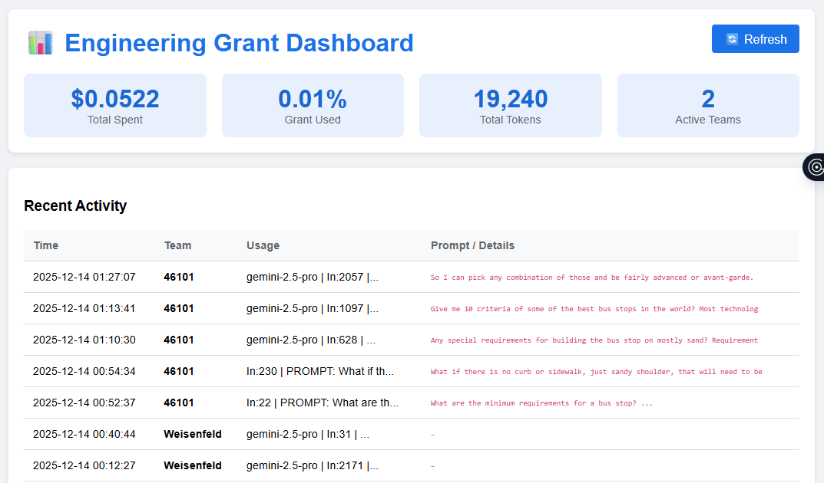
Figure 1 The Amentum Reporting Dashboard (working code at http://psd1.net/gemini/amentum_report.php) allows teachers to view real-time costs and inspect specific student queries for appropriateness.
4. Technical Hardening (Abuse Prevention)
We have implemented code-level restrictions to prevent technical abuse of the system:
- Rate Limiting: The system enforces a "cooling off" period (via visual typing indicators and server timeouts) to prevent students from spamming the API and wasting credits.
- Input Sanitization: We enforce character limits (preventing massive copy-paste attacks) and strip malicious code from inputs to prevent Cross-Site Scripting (XSS) or injection attacks.
- Model Whitelisting: The system is hard-coded to only access specific, safe versions of the Gemini model (Gemini 1.5 Pro and 2.5 Pro), preventing access to experimental or unmoderated models.
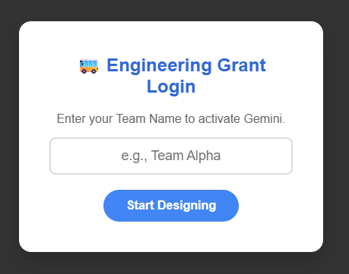
Figure 2 Students must log in using their project team name, thus further restricting access for approved purposes.

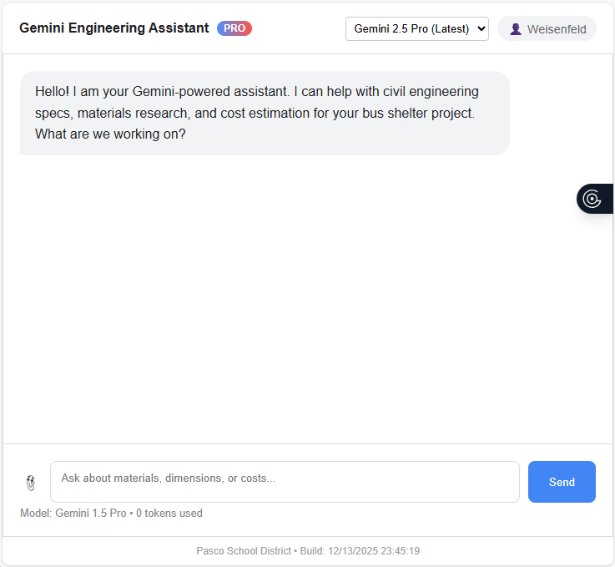
Figure 3 The Student Interface (working code at https://psd1.net/gemini ) provides a professional, distraction-free environment. Note the "Model Selection" dropdown which restricts students to approved engineering models only.
5. Educational verification
The AI is positioned as a drafter, not a decider. As part of the curriculum, students are required to verify AI outputs.
- The Rule: "Trust but verify." Students must perform manual calculations to confirm the AI's load-bearing suggestions match local Pasco municipal codes. Unverified AI data is grounds for disqualification during the final pitch.

Appendix 2: Value Proposition -- Why A Paid AI Model?
A common question regarding Artificial Intelligence in education is: "Why pay for AI access when tools like ChatGPT or Google Gemini are available to the public for free?"
The answer lies in the distinction between Consumer Chatbots and Enterprise Engineering Models. For this project to successfully simulate a Civil Engineering workflow, students require access to the latter.
This grant funds access to Gemini 1.5 Pro and Gemini 2.5 Pro via the developer API. This provides four critical capabilities that free tools cannot offer:
1. The "Jagged Frontier" of Reasoning
Professor Ethan Mollick (Wharton School, University of Pennsylvania) describes the current state of AI as a "Jagged Frontier." Users who rely on free, smaller models often interact with AI that is optimized for conversation and speed, not logic and math.
- The Free Experience: Good for writing emails or summarizing history.
- The Paid Experience (Grant Funded): Essential for complex reasoning tasks, such as cross-referencing three different sections of a municipal building code to determine a setback requirement.
- Why it matters: If we use free models, students will receive "hallucinations"—plausible-sounding but mathematically incorrect engineering advice. By funding access to top-tier "Pro" models, we provide students with a "Junior Engineer" capable of genuine analytical support.
2. Context Window: The "Memory" Problem
Civil Engineering is not done in a vacuum; it requires processing massive amounts of context (site photos, ADA compliance PDF manuals, zoning laws).
- Free Models: Have a small "context window" (memory). If you paste a long building code, the model "forgets" the beginning by the time it reads the end.
- Gemini 1.5 Pro (Paid API): Has a massive context window (up to 2 million tokens). This allows our students to upload the entire Pasco City Municipal Code and ask the AI to verify their design against specific local statutes. This workflow is simply impossible with free tools.
3. Data Privacy and Training
When the general public uses a free AI chatbot, their data is often used to train the next version of the model.
- Free Models: "If the product is free, you are the product." Student queries could theoretically be ingested into the public model.
- Paid API (Grant Funded): Google’s Enterprise API terms explicitly state that inputs are NOT used to train their models. By paying for tokens, we ensure that our students' intellectual property and creative work remain within the district's "Walled Garden," compliant with student privacy standards.
4. Reliability and Rate Limits
This project involves 150 students (40 teams) working simultaneously during class periods.
- Free Models: If 40 students from the same school IP address attempt to query a free AI simultaneously, the service will flag the traffic as "bot behavior" and block access immediately.
- Paid API (Grant Funded): The grant creates a reserved "lane" for our traffic. We are paying for the capacity to have 40 teams generating complex blueprints instantly and simultaneously without hitting "Capacity Full" errors.
Summary
We are asking students to perform professional-grade work; therefore, we must provide them with professional-grade tools. This grant allows Orion High School to move beyond the novelty of "chatting with a bot" and into the utility of "engineering with an intelligence."

Appendix 3: Budget Breakdown & Technical Feasibility
This appendix details the cost analysis for the $800.00 line item requested for "Access to Gemini Pro."
1. The Unit of Cost: "Tokens"
Unlike a flat-rate subscription (e.g., Netflix), Enterprise AI is billed by consumption. We pay for "tokens" (roughly equivalent to 4 characters of text).
- Input Cost: ~$1.25 per 1 million tokens (reading documents/prompts)
- Output Cost: ~$5.00 per 1 million tokens (generating answers/code)
2. The Per-Team Allocation ($20.00)
We are allocating $20.00 per student engineering firm (team). While this sounds like a small amount, in the efficiency of the API market, it provides massive capacity.
What does $20 buy a single team?
- Text Analysis: It allows a team to process approximately 5,000,000 to 10,000,000 words of text. This is enough to upload the entire Pasco Municipal Building Code, ADA manuals, and weeks of project notes without running out of credits.
- Image Analysis: Our system uses "Multimodal" models (Gemini 1.5 Pro). Students can upload sketches, photos of the current bus stop, or CAD screenshots. Even if a team uploads 1,000 images for analysis (at roughly ~258 tokens per image), it would cost less than $1.00 of their budget.
Verdict: The $20/team allocation provides a "safety buffer" of roughly 5x the expected usage, ensuring no student runs out of compute power mid-project.
3. Rate Limits & Classroom Throughput
A common failure point in school technology is "bottlenecking" when 150 students try to access a service simultaneously. We have mitigated this by using the paid Tier 1 API rather than free tiers.
- Concurrency: Our account is provisioned for Requests Per Minute (RPM) well in excess of our classroom needs. Even if all 40 teams submit a complex query at the exact same second, the Enterprise API queue can handle the load without crashing or returning "Service Unavailable" errors.
- Model Flexibility: The budget allows us to toggle between Gemini 2.5 Pro (for high-intelligence reasoning) and Gemini 2.0 Flash (for high-speed brainstorming), optimizing both cost and speed dynamically.
4. Fiscal Controls & Reimbursement
We treat these API credits as "reimbursable expenses" based on actuals, ensuring strict adherence to the grant budget.
- Dedicated Key: We have generated a specific API Key (...K2uA) solely for this project. Usage on this key is isolated from all other school activities.
- Real-Time Auditing: We utilize a custom dashboard (see Appendix 1) that reports usage per team, per day.
- Return of Funds: Because this is a consumption-based model, we only spend money when students are actively learning. Any portion of the $800 not consumed by API calls at the end of the project period will be returned to the grant fund or recycled back into the program as per Amentum guidelines.
[Insert Screenshot of Google AI Studio Usage Graph here - image_b3bb94.png or similar] Figure 3: Google AI Studio provides precise, daily logs of token consumption, allowing us to generate an exact "receipt" for the grant auditors.
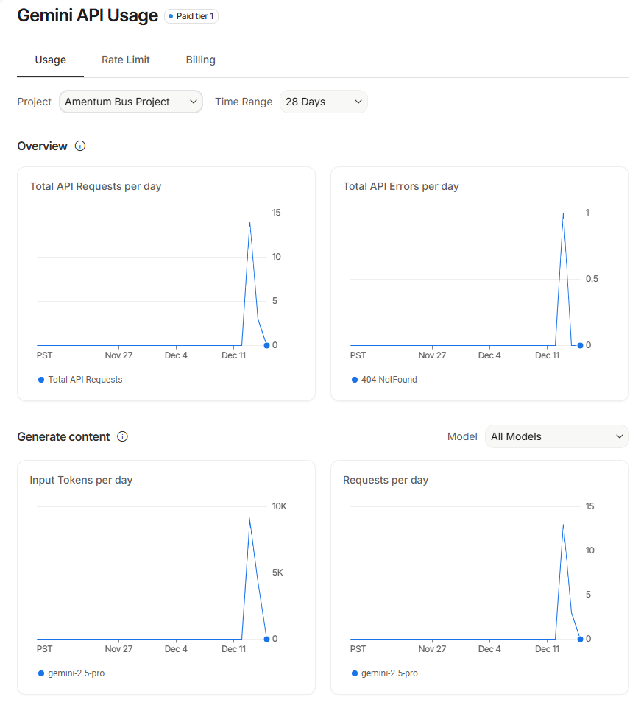
Figure 4 Google AI Studio provides precise, daily logs of token consumption, allowing us to generate an exact "receipt" for the grant auditors. This is the "Amentum Bus Project" report of how much the API has been used each day.
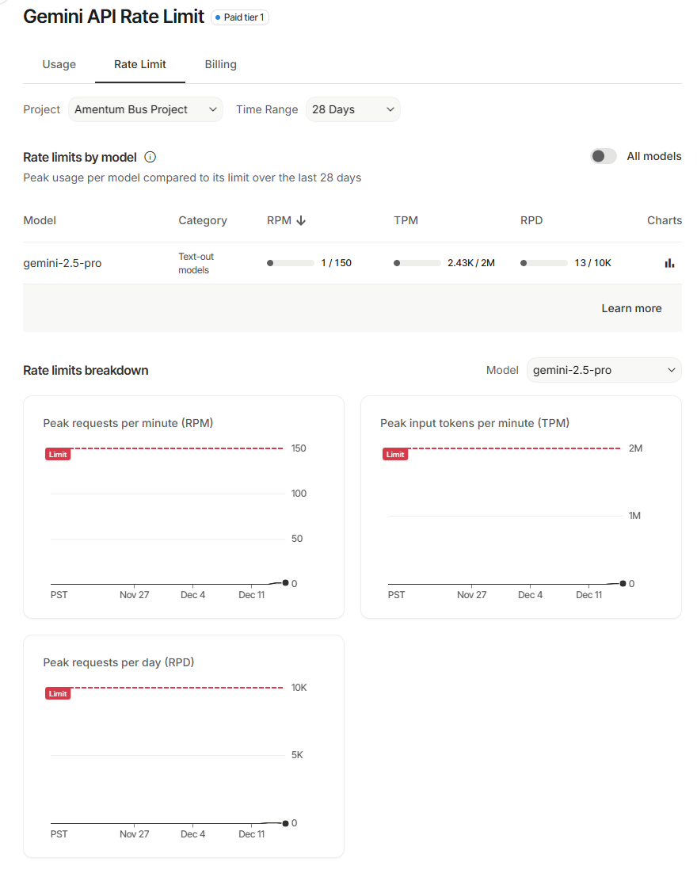
Figure 5 Google AI Studio provides precise, daily logs of token consumption, allowing us to generate an exact "receipt" for the grant auditors. This is the "Amentum Bus Project" report of how much usage we are generating relative to our usage limits.
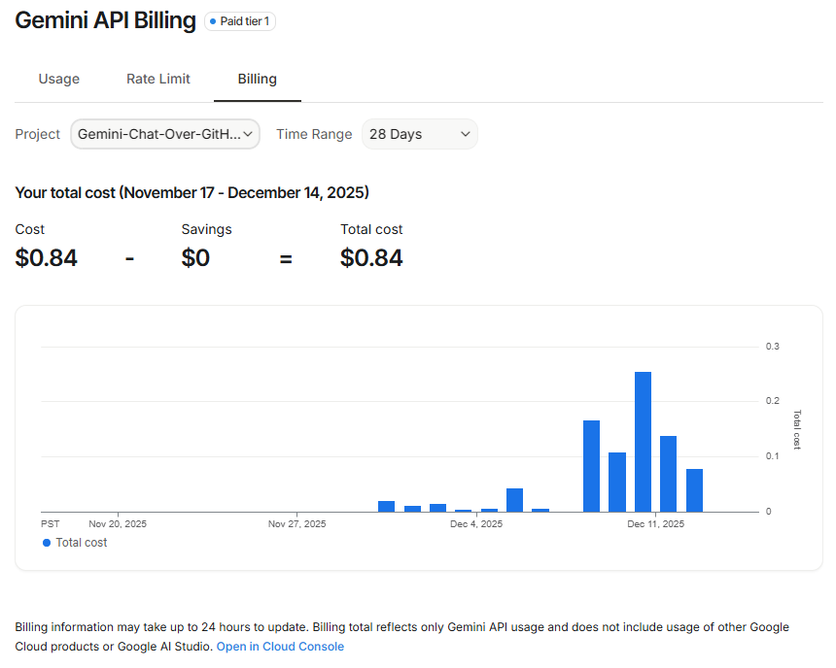
Figure 6 THIS IS NOT AMENTUM BUS PROJECT DATA. However this provides a sample of the granularity of reporting that we have month-to-month in real dollars.

Appendix 4: Sample Prompt and Output
What follows is a sample of where we hope to get with our students. The quality of the presentation and the understanding of these concepts in the answers, and how design choices that affect this prompt, all of these are our goals.
The Prompt
Act as a Lead Civil Engineer.
Act as a Lead Civil Engineer. Generate a Preliminary Design Report for a "Net-Zero Bus Shelter" in Pasco, WA.
- Load Analysis: Calculate roof load (Snow: 20psf + Wind: 110mph). Show the ASCE 7-16 formulas.
- Thermal: Design a passive "Venturi" roof and a swamp cooler system (100 sq ft).
- BOM: Provide a tabular Bill of Materials with Q4 2025 pricing for concrete, steel, and solar.

Why this prompt is substantial:
- It does Math: It forces the AI to show its work (Snow Load calculation), which students then have to check against the actual Pasco municipal code.
- It teaches Physics: The "Venturi Effect" and "Evaporative Cooling" sections force students to learn thermodynamics to understand what the AI just proposed.
- It writes Code: The final step (Python script) bridges the gap between Civil Engineering and Computer Science, hitting the "Technology Integration" grant requirement hard.
- It cannot be "faked": A student cannot just "chat" their way to this answer. They have to know what to ask. This proves that AI amplifies knowledge, it doesn't replace it.

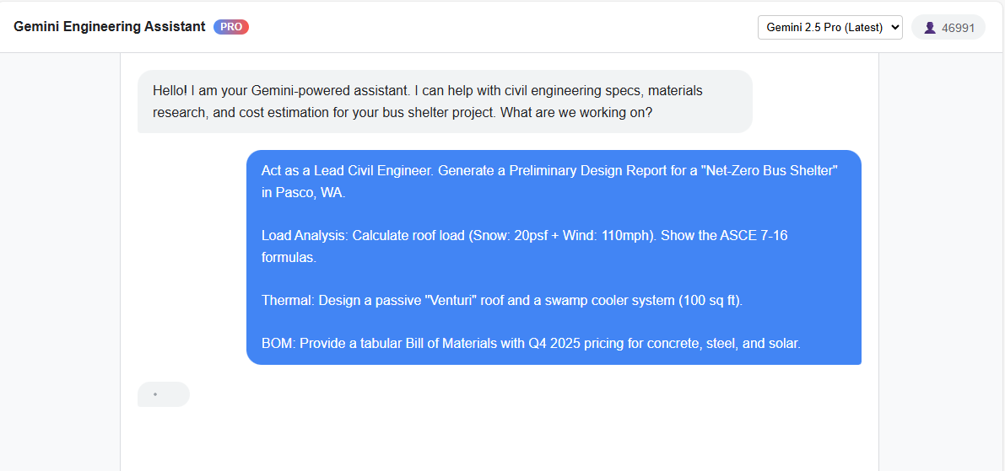

The Response
MEMORANDUM
To: Project Stakeholders
From: Lead Civil Engineer
Date: October 26, 2023
Subject: Preliminary Design Report: Net-Zero Bus Shelter, Pasco, WA
1.0 Introduction
This report outlines the preliminary design for a net-zero energy bus shelter in Pasco, Washington. The design prioritizes structural resilience, passenger comfort through passive and active cooling, and energy independence via a solar PV system.
2.0 Structural Analysis: Roof Loading
Structural design will adhere to ASCE 7-16 standards. The primary loads governing the roof design are snow and wind.
Design Parameters:
Snow Load (p_s): 20 psf (given)
Basic Wind Speed (V): 110 mph (given)
Exposure Category: C
Risk Category: II
2.1 Dead Load (D)
Estimated at 15 psf, including steel framing, roofing material, and mounted solar panels.
2.2 Snow Load (S)
The flat roof snow load p_f is taken as the ground snow load, modified by exposure and thermal factors. For this preliminary stage, the provided value is used directly.
Formula: p_s = p_f = 20 psf
2.3 Wind Load (W)
Wind pressure is calculated for the Main Wind Force Resisting System (MWFRS) using the directional procedure. The primary force will be uplift on the monoslope roof.
Formula: p = q_z G C_p
q_z: Velocity pressure at height z.
q_z = 0.00256 K_z K_zt K_d V^2
Assuming z = 10 ft, K_z = 0.85 (Exp. C), K_zt = 1.0, K_d = 0.85
q_z = 0.00256 0.85 1.0 0.85 (110)^2 = 22.3 psf
G: Gust-effect factor = 0.85 (for rigid structures).
C_p: External pressure coefficient. Assumed -0.9 for roof uplift (conservative).
Calculated Wind Pressure (Uplift):
p = 22.3 0.85 (-0.9) = -17.1 psf (Uplift)
2.4 Governing Load Combination
The design will be controlled by ASCE 7 load combinations, primarily:
1.2D + 1.6S = 1.2(15) + 1.6(20) = 50 psf (Downward)
0.9D + 1.0W = 0.9(15) - 1.0(17.1) = -3.6 psf (Net Uplift)
The structure must be designed for a 50 psf downward pressure and anchored to resist wind uplift.
3.0 Thermal Comfort Systems
Pasco’s hot, dry summers necessitate a robust cooling strategy.
3.1 Passive Venturi Roof
The roof will be designed with an aerodynamic, curved profile. Per Bernoulli's principle, wind moving over the curve accelerates, creating a low-pressure zone. This pressure differential passively pulls hot air up and out of the shelter through vents located at the roof's apex, promoting continuous airflow without energy consumption.
3.2 Evaporative Cooler (Swamp Cooler)
To supplement passive cooling during hot, still days, a small evaporative cooler system will be integrated.
Sizing: A unit rated for 100 sq ft will be sufficient.
Operation: The system will draw air through a water-saturated medium, cooling it via evaporation. It is highly effective in Pasco’s low-humidity climate.
- Power: The unit's fan and water pump will be powered directly by the onboard solar PV system.

4.0 Preliminary Bill of Materials (BOM)
Pricing is an estimate for Q4 2025 and includes materials and installation.
| Item | Description | Quantity | Unit | Unit Cost (Q4 2025 est.) | Total Cost |
| -------------------- | ---------------------------------------------- | -------- | ---- | ------------------------ | ---------- |
| Concrete | 4000 psi slab-on-grade foundation (6" thick) | 4.5 | CY | $450.00 | $2,025.00 |
| Structural Steel | HSS columns, beams, and roof purlins (A500) | 1,500 | lbs | $3.50 | $5,250.00 |
| Solar PV System | 2kW panels, inverter, mounting, 5kWh battery | 1 | LS | $9,000.00 | $9,000.00 |
| Total Estimated Cost | | | | | $16,275.00 |
5.0 Conclusion
The proposed design is feasible and meets the project objectives. The structure is robust, and the integrated thermal systems will provide significant passenger comfort while achieving net-zero energy operation. We recommend proceeding to the detailed design phase.

Getting students to understand that information so that they can present and defend it is key. But also doing a followup prompt for clarification or validation.
The Follow-Up Prompt (Validation / Verification)
"Excellent. Now, based on those load numbers, write a Python script that I can run to verify the Wind Uplift and Snow Load calculations."

And here is the response which can be graphed or manipulated to show tradeoffs in design or material specifications.
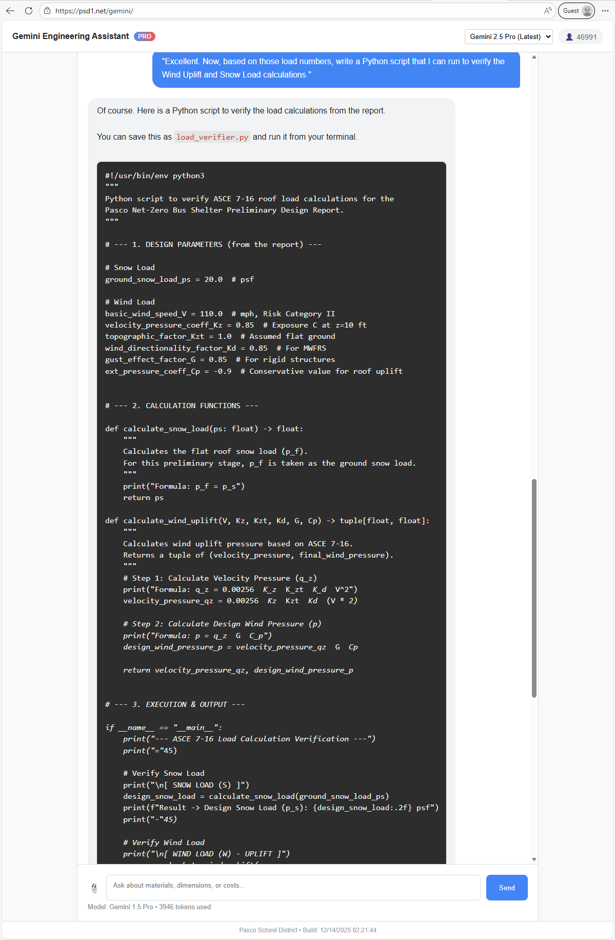
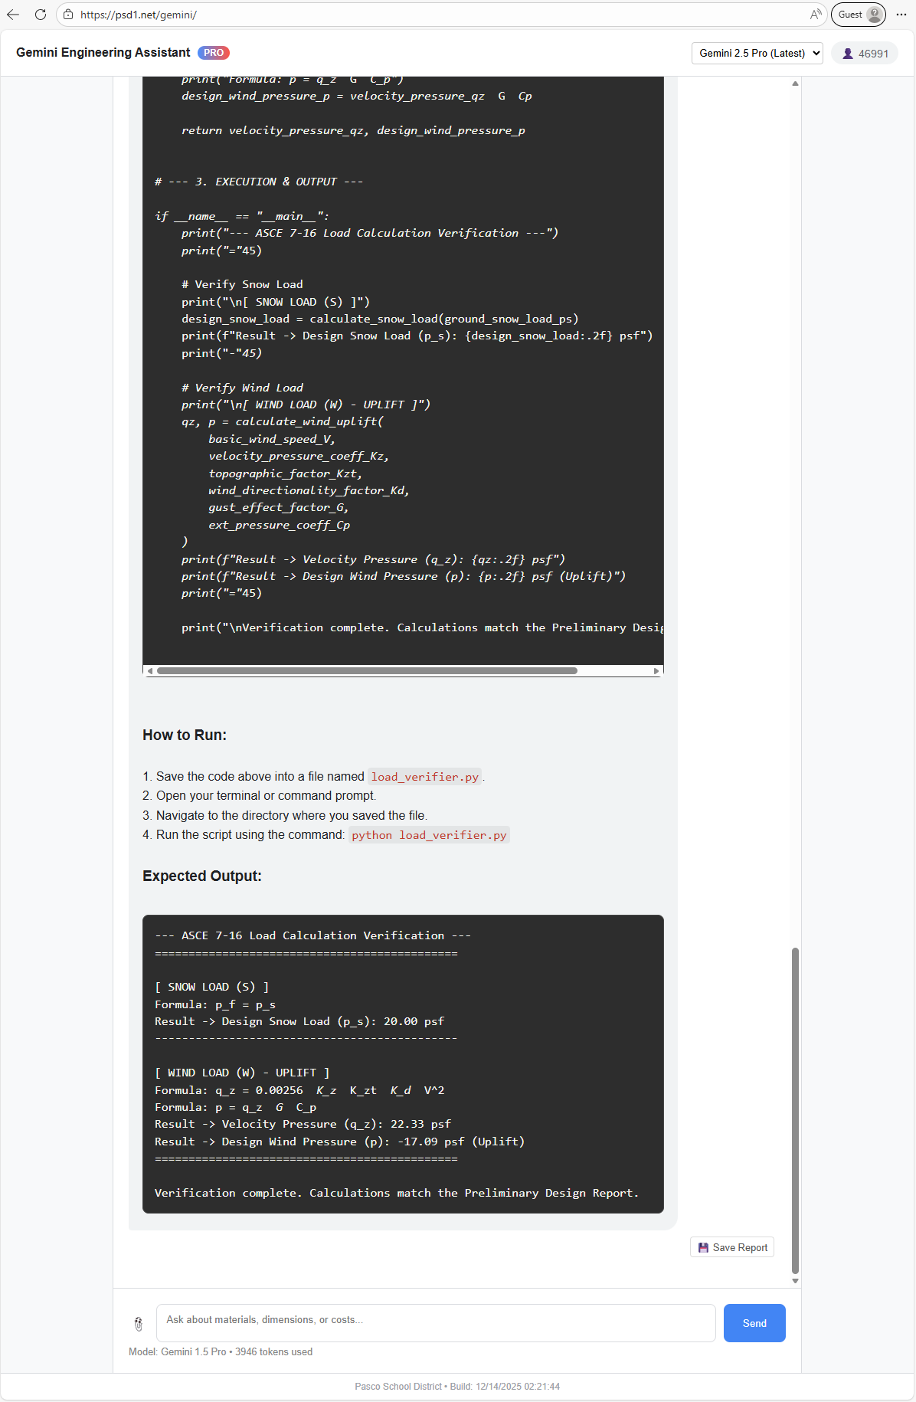

Appendix 5: Why Gemini and not Chat GPT or Claude?
Our decision to utilize Google Gemini—specifically the next-generation Gemini 2.5 Pro model—over competitors like OpenAI’s ChatGPT or Anthropic’s Claude is a deliberate choice to provide students with "frontier" technology that exceeds standard consumer capabilities.
While other models are excellent for conversation, Gemini 2.5 Pro offers three distinct engineering advantages that are critical for this project:
1. Access to the "Bleeding Edge" (The 2.5 Advantage)
Most "AI in Education" projects rely on standard, publicly available models (like GPT-4o or Claude 3.5). By utilizing the developer API, our students are gaining access to Gemini 2.5 Pro, a model class that represents the absolute newest tier of reasoning capabilities often unavailable to the general public.
- Why it matters: We aren't just teaching students how to use today's tools; we are giving them hands-on experience with tomorrow's reasoning engines. This specific model outperforms predecessors in complex instruction following—critical when asking an AI to "Act as a Civil Engineer and strictly follow ASCE 7-16 wind load protocols."
2. The "Context Window" Advantage (Infinite Memory)
Civil Engineering requires synthesizing massive amounts of documentation simultaneously. A student cannot design a compliant bus shelter without cross-referencing the International Building Code, Pasco Zoning Maps, and the 279-page ADA Standards manual.
- The Competitors: Most models (like GPT-4o) are limited to ~128k tokens. If we feed them all these documents, they "forget" the beginning of the first PDF before finishing the last.
- Gemini 2.5 Pro: Inherits the massive 2 Million token context window of the Gemini family. This allows students to upload every single relevant municipal code and manual into the AI's working memory at once. It is the only platform capable of "holding the whole problem in its head," allowing for a true holistic engineering audit.
3. Native Multimodality (Sight vs. Simulation)
Most AI models are "text-first" and treat images as an afterthought. Gemini 2.5 Pro was built from the ground up to be Native Multimodal.
- The Application: Our students are starting with a "Sad Patch of Dirt." They need to upload video walk-throughs and panoramic photos of the actual site.
- The Difference: While other models can "see" a photo, Gemini 2.5 Pro demonstrates superior capability in reasoning over visual data—identifying specific drainage issues from a video clip or estimating grade changes from a photo. It acts as a second set of eyes on the job site, not just a text generator.
Conclusion
We admire ChatGPT for its fluency and Claude for its coding. However, this is an Engineering Project. We chose Gemini 2.5 Pro because it is the only tool that combines next-generation reasoning, infinite context, and native vision—the exact three traits required to turn a high school student into a junior civil engineer.

